Shawn Dell Joyce paintings have risen in value by more than 50% in the past ten years!

The ROI in the stock market, real estate and other investments is less than investing in the career of an emerging artist. When you invest in a person who is driven and ambitious, your investing in their hopes and dreams, and helping to make them come true. The more you invest, and tell your friends about her work, the more the value of her work rises, and the value of your investment rises at the same time!

How the art market works… If you have ever wondered why someone would pay $250K for a banana duct-taped to a wall you are not alone. The art market is based on gossip-a gallery invests in an unknown artist. The gallery sells the work of this unknown to their top 10 collectors promising an enormous rate of return. They buy, the price goes up, the gallery made their money. But they don’t stop there! Instead, the gallery pays for full page ads, and hosts a sold out show driving prices even higher. Collectors clamor for more works. The initial collectors sell off their initial investment and make even more money inflating the prices even more.

When you work with the artist and small galleries who do not operate this way, your building an investment more slowly and steadily. This keeps prices rising consistently, with less likelihood of crashing. This protects your investment and makes it more stable and long term. Plus its honorable and has integrity.

How Shawn’s prices have grown…Over 20 years, prices have gradually increased and values of art have grown. Each artist is unique since careers grow at different rates. On the next page is a breakdown of how much a framed painting by Shawn Dell Joyce cost in 2010, 2015, 2020 so you can see the how the value has accrued over time.

Shawn Dell Joyce Pricing for 16x20 Framed Pastel

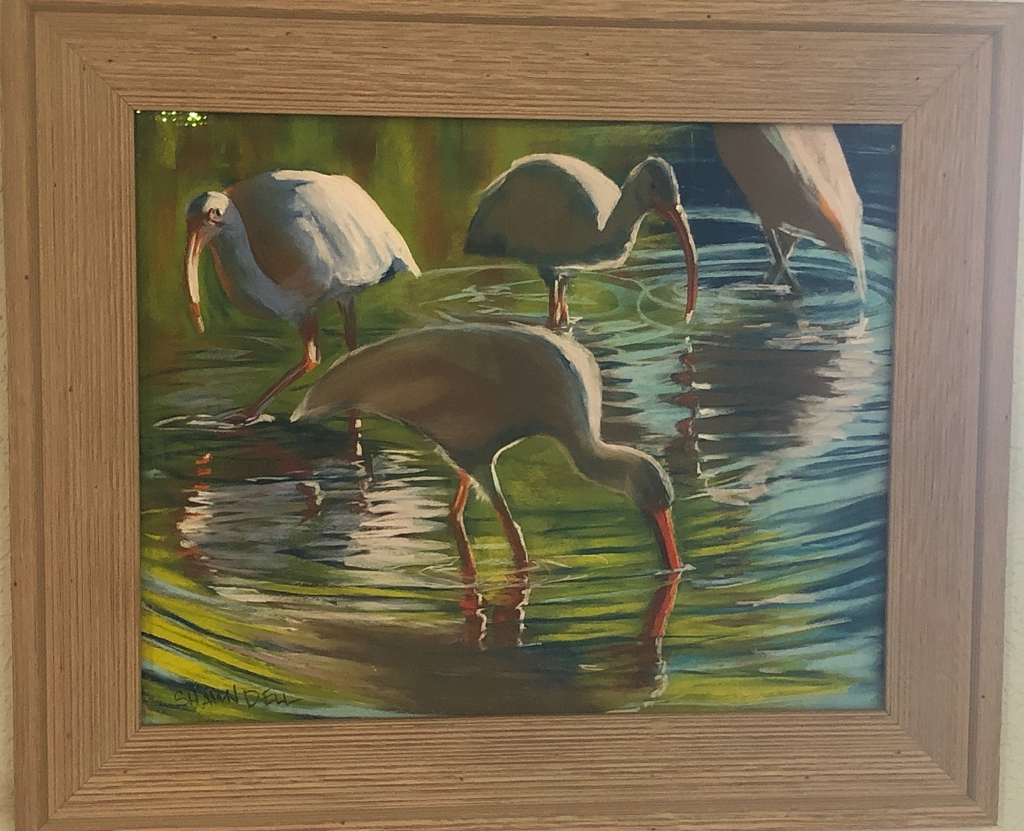

2000 Price of framed 16x20 pastel through James Douglas Gallery
$400
2005 Price of framed 16x20 pastel through Wallkill River Art Gallery
$450
2010 Price of framed 16x20 pastel through Wallkill River Art Gallery
$500
2015 Price of framed 16x20 pastel through Beach House Gallery
$600
2020 Price of framed 16x20 pastel through Woodfield Fine Art
$800

