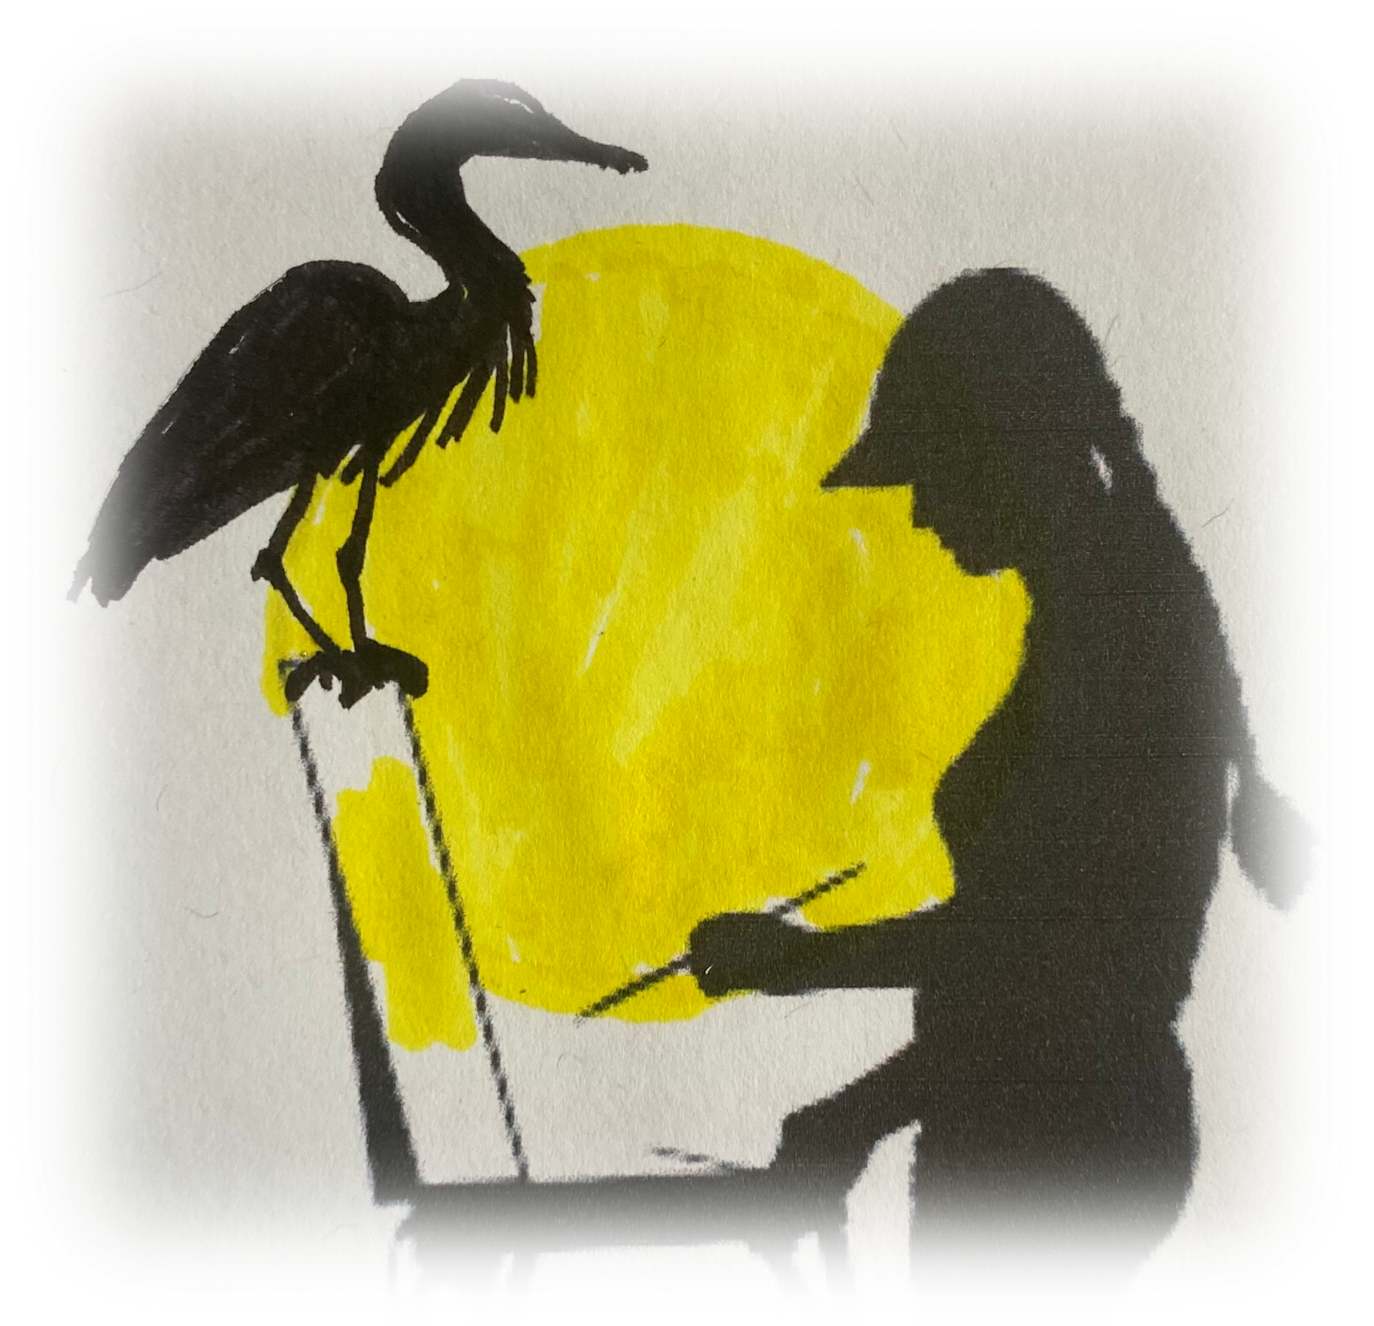  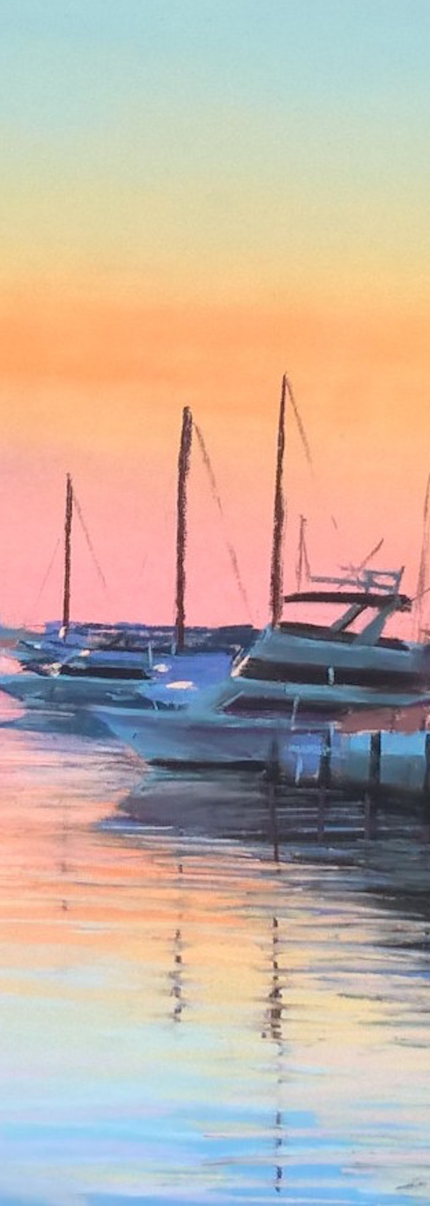 | Plein Air Adventure  www.shawndelljoyce.com | Phone: 845-728-4001  shawndelljoyce@gmail.com
Plein Air Adventure Materials List
Shawn Dell Joyce
shawndelljoyce@gmail.com
CELL FOR TEXTS AND CALLS (845) 728-4001

• Easel, table with chair, drawing board and chair, etc. Best chois is something you can fit into a backpack
Most sites involve a small walk or hike over sand. Try to keep it simple and carry as little as possible.

If you are working in oils:
- Solvent container with clamping lid
- Small sketch pad w/ pencil or marker
- Oil paint (basic colors, plus thalo blue for Florida skies!)
- Brushes (plus palette/painting knife, sponge)
- Canvas, or Ampersand panels, or other support 12x16 or smaller work best
- Solvent - (Gamsol or Turpenoid).

If you are working in pastel:
- Set of 24 pastels
- 9x12or 12x16 pastel paper/or Ampersand Pastelbord or other support (I use Ampersand Pastelbord)
- clip board to attach it too

If you work in watercolor:
- set up watercolors
- watercolor block or mounted paper, or Ampersand Aquabord
- assorted watercolor brushes
- water and cup

Other materials you may need:
- towel, sketchbook and pencil, viewfinder if you have one, if not, I’ll give you one.
- Wide brimmed hat,
- light for your hat for nocturnes,
- Rose-colored glasses to reduce the landscape to values
- packaging like an empty pizza box, or wet painting carrier for finished painting.
- Don’t forget to bring PLENTY of water! It’s easy to dehydrate!
- Bug spray if you are sensitive to mosquitoes or ants. You may want to bring a towel to spread under you to stand on while you paint if ants are a problem
- A mask or face shield for group critique (optional)
- Umbrella or sunscreen if you need it

Directions:
You will be given GPSable addresses and usually a maplink for directions. You are responsible for getting yourself to the site safely. You may want to scout it a day or two ahead of class so you know exactly where it is.
If you are lost and can’t find us, text me (845) 728-4001 and I will send you my location which you can GPS directly to me.

Parking and Park Fees: Many of the sites will require a fee for parking. This is a tourist-
Dependent county so plan on spending some $ on parking. Sites with parking fees are mentioned in the site list.

Plein air painting tips with Shawn Dell Joyce

Set up: Be careful where you set up! Make sure you are not in the stream of traffic, full sun, or too shady. Get the best view.

Start: Make 3 thumbnail sketches using your viewfinder to simplify the landscape. Make sure to capture 3-5 values on each sketch. Work out different composition patterns in these sketches. Better to make your mistakes on a small scale at this phase than later when you have to commit time and expensive art supplies toward it!

Transfer: Choose the sketch that resonates most with your inner vision to be the start of your painting. Transfer that sketch to your canvas using a grid system or crosshairs. Make the sketch as detailed as you wish but keep in mind that as soon as you apply color, your sketch will disappear! Its main purpose is to help you visualize your finished painting.

Color: Lay out your palette in families of values-have at least 5 values from dark to light for each family. If you are painting a landscape, have a family of greens, blues, and whatever other color your subject is. If you have your values ready, you wont have to “hunt and peck” for the right color. Most of my paintings are made with 20 or less pastels.

Check Your Perspective! Once you have your colors ready and your support sketched out. Take three giant steps backwards and look at your sketch. Check the perspective. Is the vanishing point clear? Are the lines parallel that need to be? Is that roof pitched correct? Clear up any mistakes now.

Block In: Work the entire painting starting with blocking in the big shapes. I usually start from the back and work forward and from dark to light. My painting would start with the sky and distant hills, then the middle ground, and last the foreground where most of the darks will be.

Focal Point: Step back after the whole surface is blocked in, and your pattern of darks are established. Decide at that point where the focal point will be. This will inevitably be where the darkest dark meets the lightest light. Make sure you know what your focal is or you will make a dreamy, unfocused painting that is easily forgettable.

Dark to light: Start laying in your darks and working up to your lights. I start with 5; darkest darks and put them everywhere I see them. Then I move to 4’s and put in all the next darkest colors here they go, then the 3’s which is local color which may have been laid in during the “block in” phase, then 2’s which are reflected light and light spots, and finally the 1’s which are your highlights. At this point you are done!

Evaluate: Step back 3 giant steps and critique your work. Is there a strong pattern of lights and darks? Are there any glaring perspective problems or value problems? Tweak anything that needs tweaking and show it to a peer.

Remember that each painting is a study to help you grow. Think of them as steps in the right direction instead of successes or failures!

